Problem F1: Büchi Automata
a) Briefly describe the difference between Büchi Automata and deterministic finite automata (DFA).

For deterministic finite automates the word must end up in the final states of it (and naturally give no error while passing through the automate), then we determine that the word belongs to the automat.

In case of Büchi Automates, we are able to make claims about infinite words. We say that if the final state is met infinite times during the passing of the word through the automate, then the automate recognizes the word.

b) Find an LTL formula describing the words accepted by the following Büchi Automata with = fa; b; cg.
An edge with label can be taken with any input symbol. Hint: Unary operators have precedence over
binary operators. For everything else, use parentheses.

1)
G(((b ∨ c)Ua) → ((bUc) → G(b ∨ c))) ∨ G(b ∨ c)

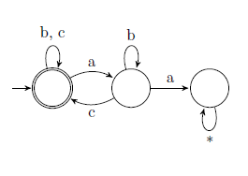

2)
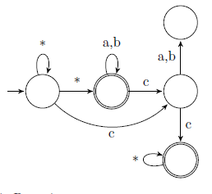
(c ∧ Xc) ∨ (F(a ∨ b)) ∨ (F(a ∨ b)U(c ∧ Xc))

3)
(bUa)UF(bUc)
